**Code:**

import pandas as pd

import numpy as np

import matplotlib.pyplot as plt

import seaborn as sns

import random

dataset = pd.read_csv("/content/E-commerce Customer Behavior - Sheet1.csv")

dataset.head()

features = ['Total Spend', 'Items Purchased', 'Days Since Last Purchase', 'Average Rating']

X = np.array(dataset[features])

def calculate_distance(a, b):

    return np.sqrt(np.sum((a - b) ** 2))

def assign_clusters(centroids, X):

    assigned_cluster = []

    for i in X:

        distances = [calculate_distance(i, c) for c in centroids]

        assigned_cluster.append(np.argmin(distances))

    return assigned_cluster

def update_centroids(clusters, X):

    new_centroids = []

    df_temp = pd.concat([pd.DataFrame(X), pd.Series(clusters, name='cluster')], axis=1)

    for c in set(df_temp['cluster']):

        current_cluster = df_temp[df_temp['cluster'] == c][df_temp.columns[:-1]]

        cluster_mean = current_cluster.mean(axis=0)

        new_centroids.append(cluster_mean)

    return np.array(new_centroids)

k = 3

init_indices = random.sample(range(len(X)), k)

centroids = np.array([X[i] for i in init_indices])

print("Initial Centroids:\n", centroids)

epochs = 10

for i in range(epochs):

    clusters = assign_clusters(centroids, X)

    centroids = update_centroids(clusters, X)

    if i == 0 or i == epochs - 1:

        plt.figure(figsize=(10,7))

        plt.scatter(X[:,0], X[:,1], c=clusters, alpha=0.3)

        plt.scatter(centroids[:,0], centroids[:,1], color='black', marker='X', s=200)

        plt.title(f'K-Means Clustering - Iteration {i+1}')

        plt.xlabel(features[0])

        plt.ylabel(features[1])

        plt.show()

dataset['Cluster'] = clusters

for i in range(k):

    print(f"\nCluster {i} Summary:")

    print(dataset[dataset['Cluster']==i][features].describe())

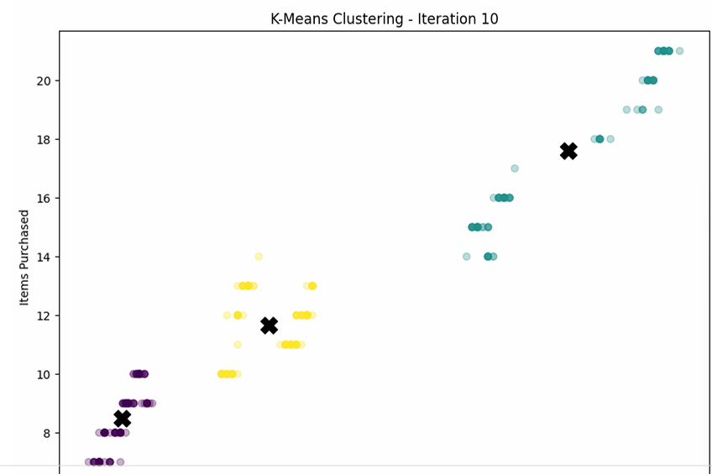**Results:**

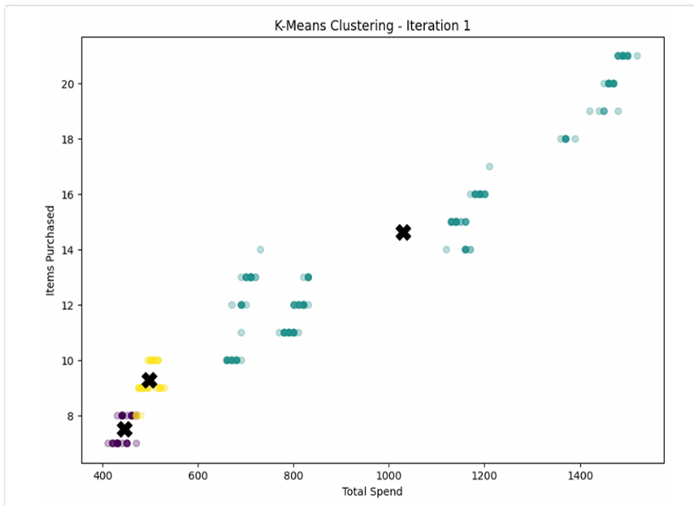

**Conclusion:** In this assignment, we learned how to use K-Means clustering to group customers based on their shopping behavior. It helped us identify loyal buyers, moderate shoppers, and low-engagement customers, showing how data can guide better business decisions.